Grace Industries | In-Command® or Grace-Watch® Quick Start Guide
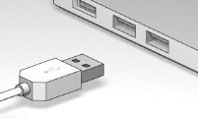
- Always Install USB drivers in step 1 before connecting Grace Equipment.
*Program installation requires Administrative privileges

 | Install Drivers and Software

Insert the In-Command® or Grace-Watch® installation CD into your computer. The product installation splash screen should appear after several seconds.

*If the Install Software did not come up on the screen automatically as described, then you will
need to manually launch the installation. Open “My Computer,” select the CD/DVD Drive with the
Installation disk in it, then double-click on “ICLaunch.exe” for In-Command® or “GWLaunch.exe” for
Grace-Watch®. This will launch the product splash screen.

Install USB Driver
Press the Install button and a command window will open showing the install progress and completion.

Install Software
Press the Install button and follow the on screen instructions.
- Agree to the End User License.
- Provide the Grace Software key to complete the installation.
  - Software Key can be located on the CD Case or may have been provided via email.

This is the only software required at this time. Other tools on the CD can be installed or referenced at a
later time or on an as needed basis. There is also a link to the Product Manual than can be viewed
at any time.

*You should wait until Step 2 below is completed before running the software

 | Plug In USB Receiver(s)

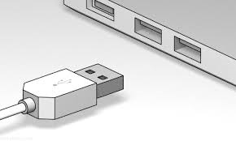

Once plugged in, Windows will create a COM Port for the new device using the driver that was installed
in step 1. You can verify the port was created by looking under Ports in Windows Device Manager.

 | Configure the COM port and In-Command®/Grace-Watch® Software

Configure COM
- Run In-Command® or Grace-Watch®.
- Go to Configure/System Setup/Configure Connections.
- Enter the Connection Type and select the COM Port created in step 2.
- Use appropriate Baud Rate for your device: Watchdog® = 19200, MX = 9600, MXH = 38400
  - WatchDog® and MX are Legacy Grace products.
  - MXH is associated with the TPASS®5 and the most recent TPASS®- H and SC500-H devices
- Press Save when finished

Configure ID
- Go to Configure/System Setup/System Settings.
- Set the System ID to match the ID of your PASS Device(s) ex: Device 10-05 would use System ID 10.
  - PASS device ID’s can be found on the device Clip.
  - SC500 ID can be found on the display.
- Additional ID’s can be monitored by assigning more ID’s under the Aux ID’s tab.

Configure Names
- Go to Configure/User Setup.
- Press the Create a Name File button.
- Accept defaults and press the “Create Name File” button. You will be prompted to name and save
the file.
- From Configure/User Setup, press the “Choose Active Name File” button and select the Name file
created in the previous step.

 | Start an Incident

The Start Incident button is located at the bottom center of the Programs main landing page.
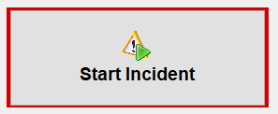

In order to Start an incident, the Start Incident button must be enabled and flashing red. There are 2 things
that control this.

1) The USB device must be plugged in and correctly configured. See Steps 1 and 2 above
2) There are 2 required fields on the Incident Data Section of the main landing page. These fields must be
populated before an Incident can be started. They are “Incident Type” and “Incident Position”.

*Required fields can be set to automatically populate by setting the defaults under Configure/Incident
Setup/Types and Configure/Incident Setup/Positions

Press the “Start Incident” button to begin monitoring!

